# Problem 0 : Part A (15 mins):

## Playing with JSON object’s Values:

Fluffy sorry, Fluffyy is my fav cat and it has 2 catFriends  
Write a code to get the below details of Fluffyy so that  
I can take him to vet.

var cat = {  
 name: ‘Fluffy’,  
 activities: [‘play’, ‘eat cat food’],  
 catFriends: [  
 {  
 name: ‘bar’,  
 activities: [‘be grumpy’, ‘eat bread omblet’],  
 weight: 8,  
 furcolor: ‘white’  
 },   
 {  
 name: ‘foo’,  
 activities: [‘sleep’, ‘pre-sleep naps’],  
 weight: 3  
 }  
 ]  
}console.log(cat);

# ****Basic Tasks to play with JSON****

1. Add height and weight to Fluffy
2. Fluffy name is spelled wrongly. Update it to Fluffyy
3. List all the activities of Fluffyy’s catFriends.
4. Print the catFriends names.
5. Print the total weight of catFriends
6. Print the total activities of all cats (op:6)
7. Add 2 more activities to bar & foo cats
8. Update the fur color of bar

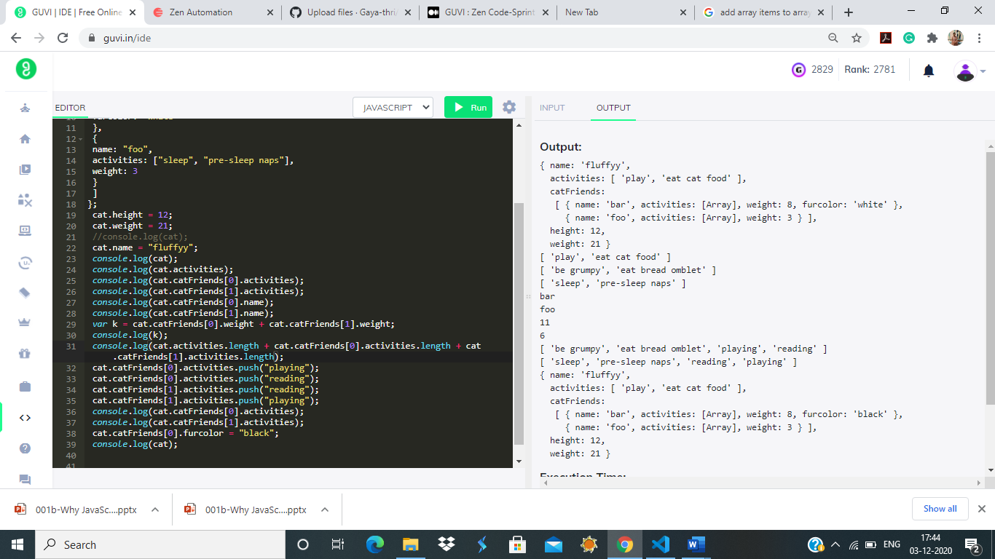

# Problem 0 : Part B (15 mins):

## Iterating with JSON object’s Values

Above is some information about my car. As you can see, I am not the best driver.  
I have caused a few accidents.  
Please update this driving record so that I can feel better about my driving skills.

var myCar = {  
 make: ‘Bugatti’,  
 model: ‘Bugatti La Voiture Noire’,  
 year: 2019,  
 accidents: [  
 {  
 date: ‘3/15/2019’,  
 damage_points: ‘5000’,  
 atFaultForAccident: true  
 },  
 {  
 date: ‘7/4/2022’,  
 damage_points: ‘2200’,  
 atFaultForAccident: true  
 },  
 {  
 date: ‘6/22/2021’,  
 damage_points: ‘7900’,  
 atFaultForAccident: true  
 }  
 ]  
}

1. Loop over the accidents array. Change atFaultForAccident from true to false.

2. Print the dated of my accidents

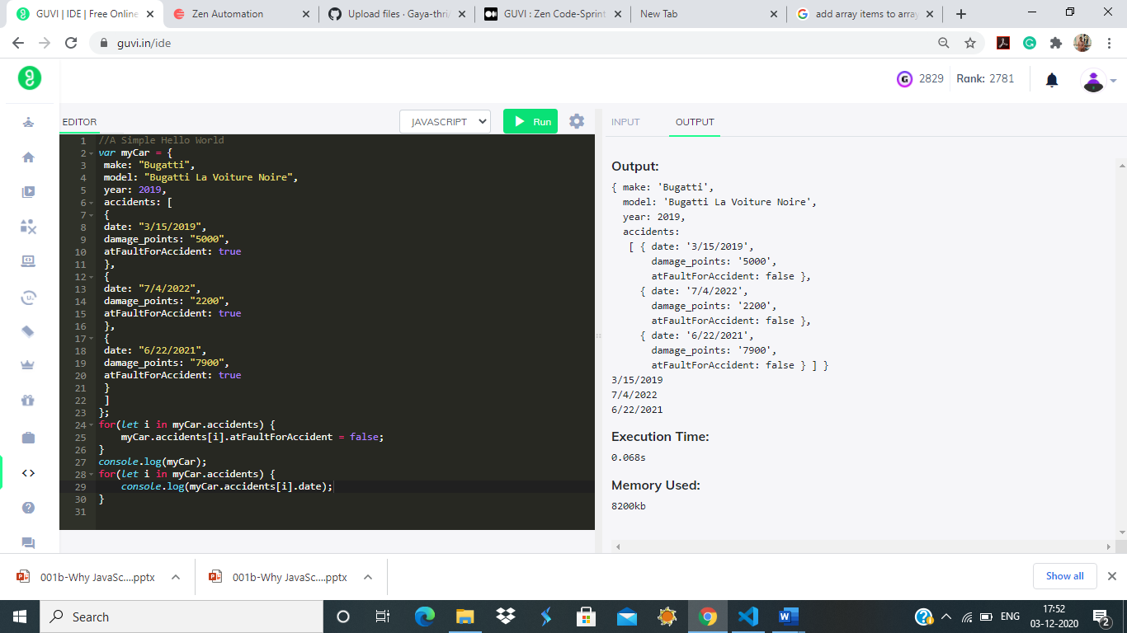

1.Write a function called “printAllValues” which returns an newArray of all the input object’s values.

Input (Object):

var object = {name: “RajiniKanth”, age: 33, hasPets : false};  
Output:

[“RajiniKanth”, 33, false]

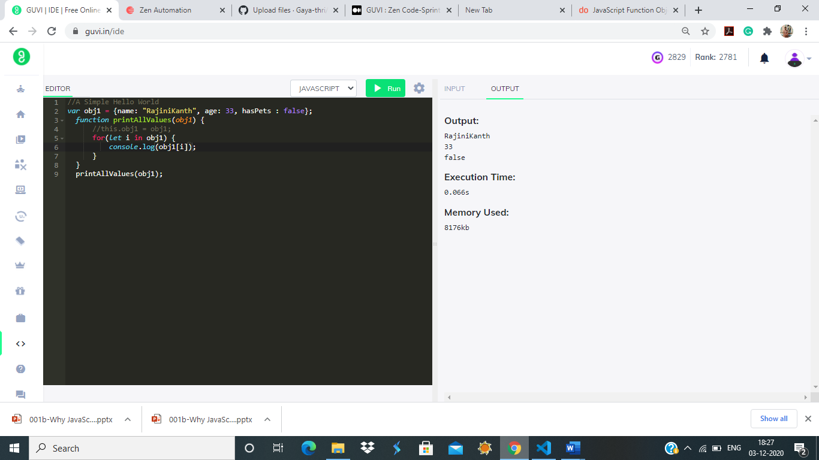

2.Write a function called “printAllKeys” which returns an newArray of all the input object’s keys.

Example Input:  
{name : ‘RajiniKanth’, age : 25, hasPets : true}  
Example Output:  
[‘name’, ‘age’, ‘hasPets’]

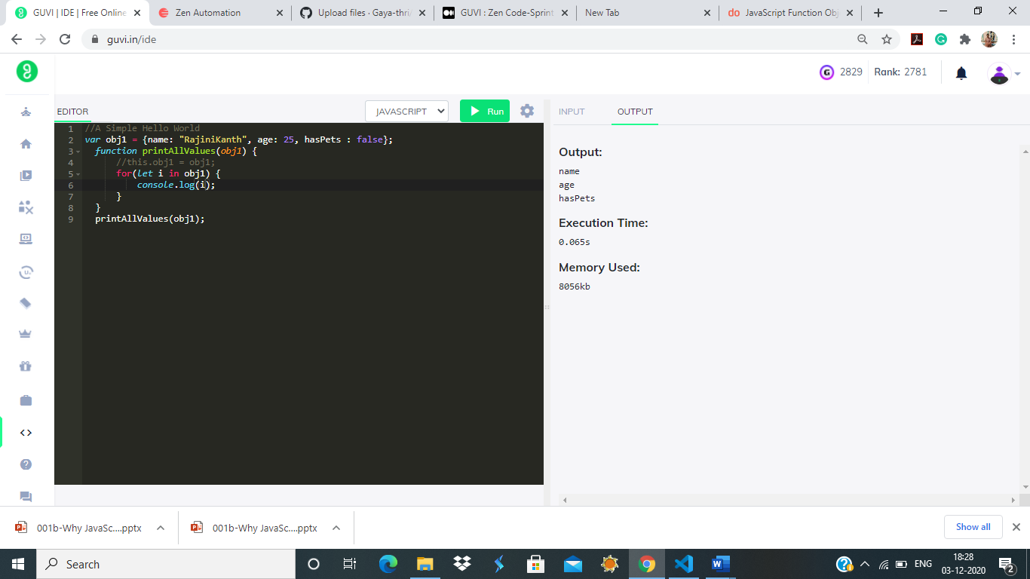

3.Write a function called “convertObjectToList” which converts an object literal into an array of arrays.  
Input (Object):  
var object = {name: “ISRO”, age: 35, role: “Scientist”};  
Output:  
[[“name”, “ISRO”], [“age”, 35], [“role”, “Scientist”]]

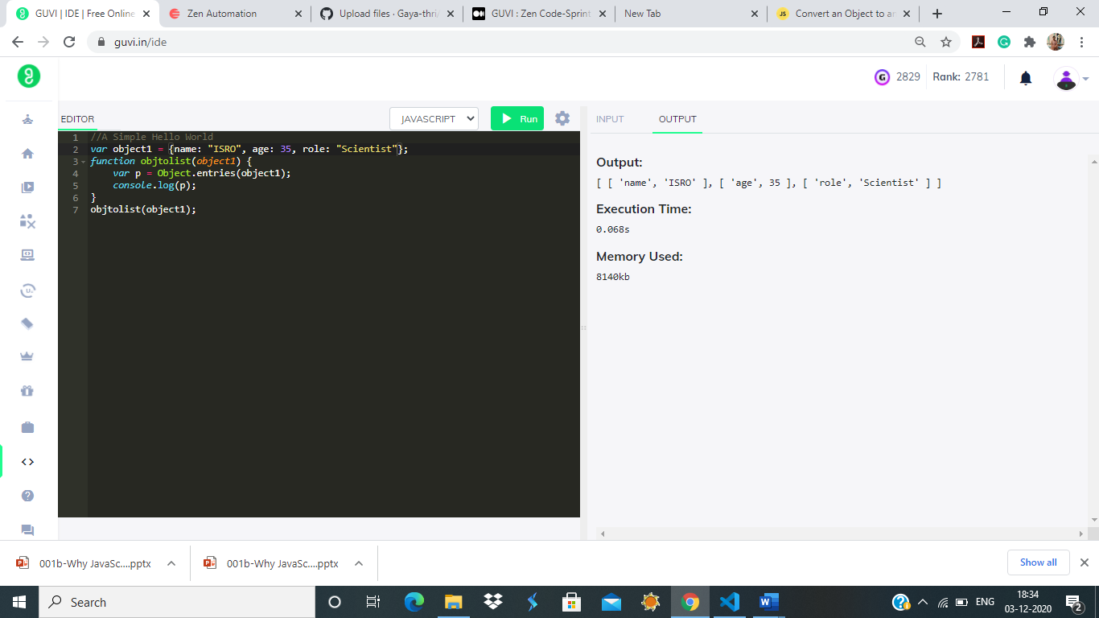

4.Write a function ‘transformFirstAndLast’ that takes in an array, and returns an object with:  
1) the first element of the array as the object’s key, and  
2) the last element of the array as that key’s value.  
Input (Array):  
var array = [“GUVI”, “I”, “am”, “Geek”];  
Output:  
var object = {  
GUVI : “Geek”  
}

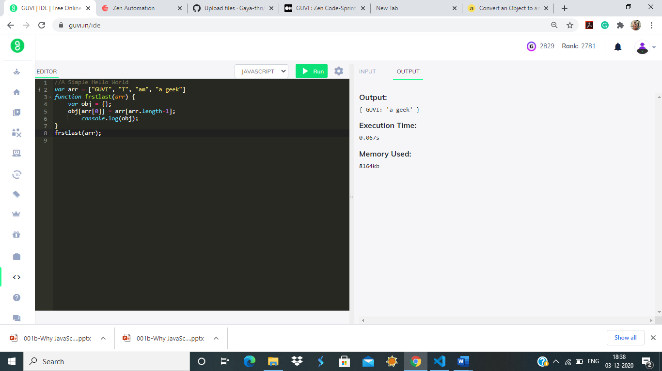

5.Write a function “fromListToObject” which takes in an array of arrays, and returns an object with each pair of elements in the array as a key-value pair.  
Input (Array):  
var array = [[“make”, “Ford”], [“model”, “Mustang”], [“year”, 1964]];  
Output:  
var object = {  
make : “Ford”  
model : “Mustang”,  
year : 1964  
}

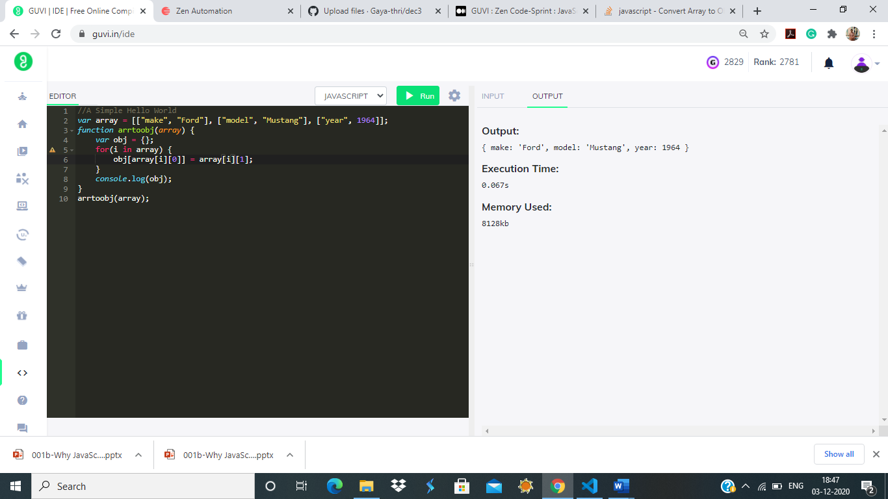

## 6.Parsing a list of lists and convert into a JSON object:

Write a function called “transformGeekData” that transforms some set of data from one format to another.

Input (Array):  
var array = [[[“firstName”, “Vasanth”], [“lastName”, “Raja”], [“age”, 24], [“role”, “JSWizard”]], [[“firstName”, “Sri”], [“lastName”, “Devi”], [“age”, 28], [“role”, “Coder”]]];

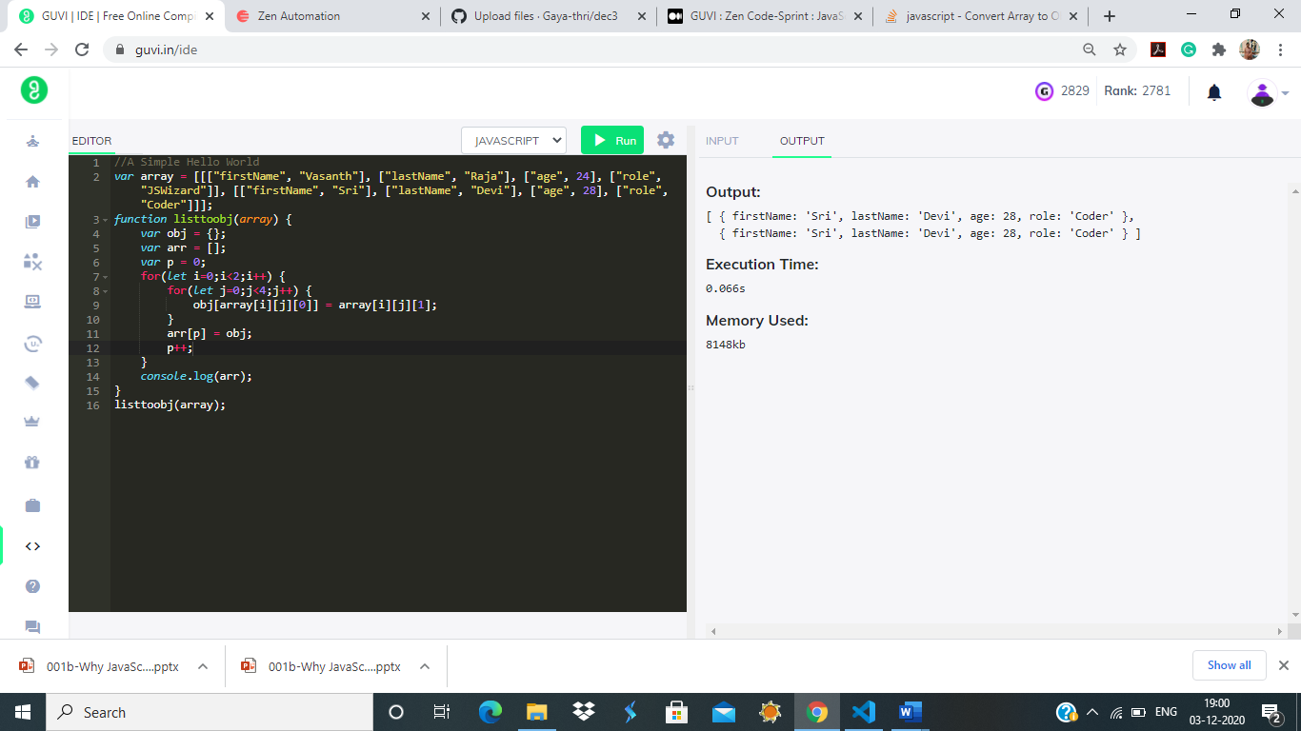

## 7.Parsing JSON objects and Compare:

I have a mock data of security Questions and Answers. You function should take the object and a pair of strings and should return if the quest is present and if its valid answer

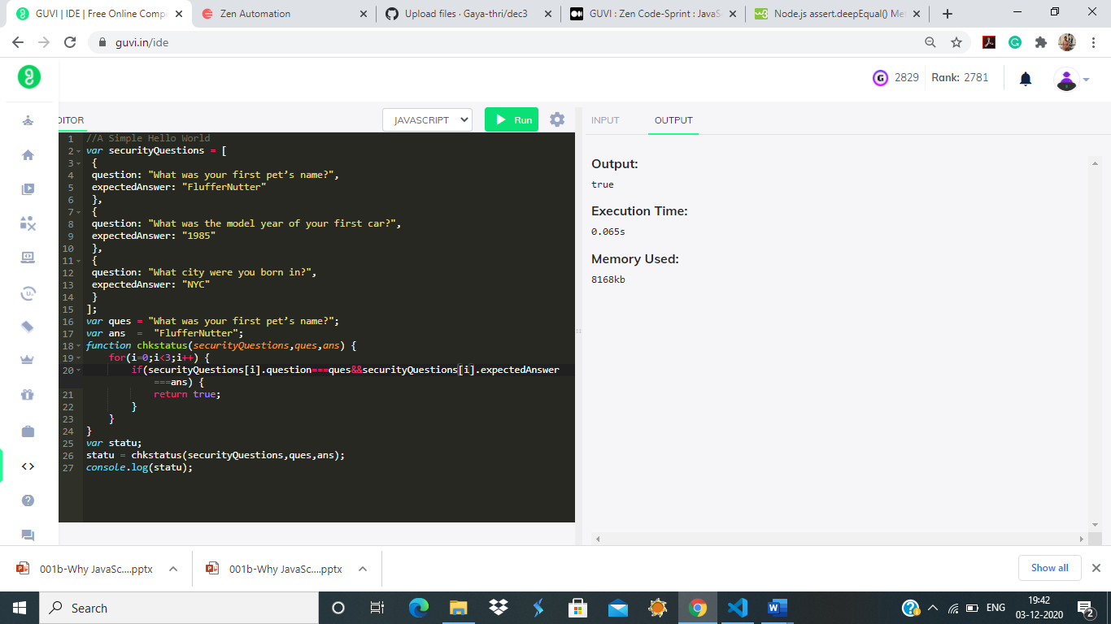

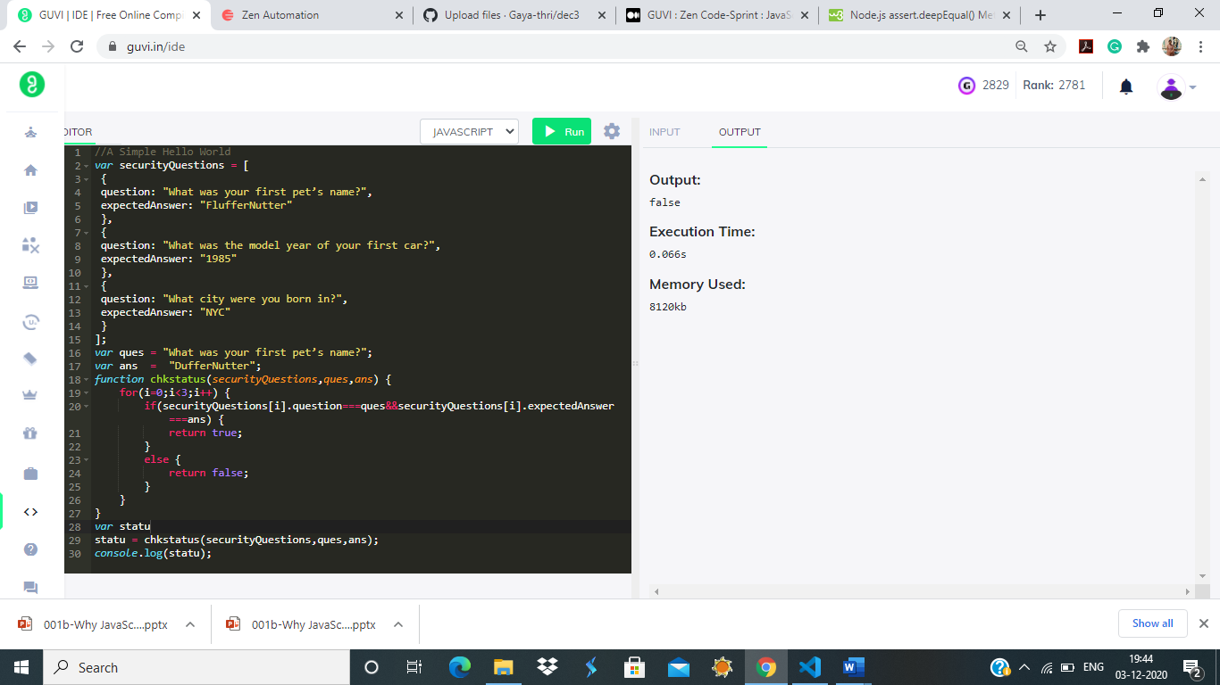

8.Write a function to return the list of characters below 20 age:

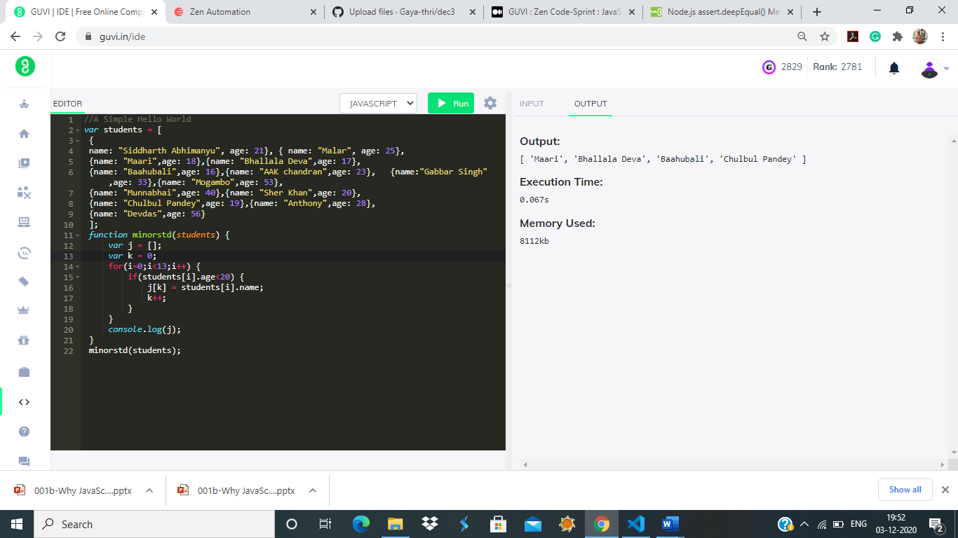

9.Write an “assertObjectsEqual” function from scratch.  
Assume that the objects in question contain only scalar values (i.e., simple values like strings or numbers).  
It is OK to use JSON.stringify().  
Note: The examples below represent different use cases for the same test. In practice, you should never have multiple tests with the same name.  
Success Case:  
Input:  
var expected = {foo: 5, bar: 6};  
var actual = {foo: 5, bar: 6}  
assertObjectsEqual(actual, expected, ‘detects that two objects are equal’);  
Output:  
Passed  
Failure Case:  
Input:var expected = {foo: 6, bar: 5};  
var actual = {foo: 5, bar: 6}  
assertObjectsEqual(actual, expected, ‘detects that two objects are equal’);  
Output:  
FAILED [my test] Expected {“foo”:6,”bar”:5}, but got {“foo”:5,”bar”:6}

